

**KC82**

**KC6**

**KM3**

**A**

Fig. 1. Stations sampled with a VMPS net on board the training vessel *Umitaka-maru*in the Indian sector of the Southern Ocean, January 2020.

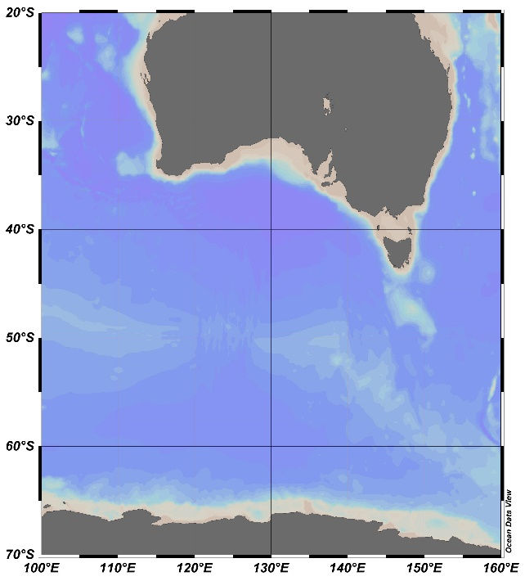

AUSTRALIA

ANTARCTICA

**A**