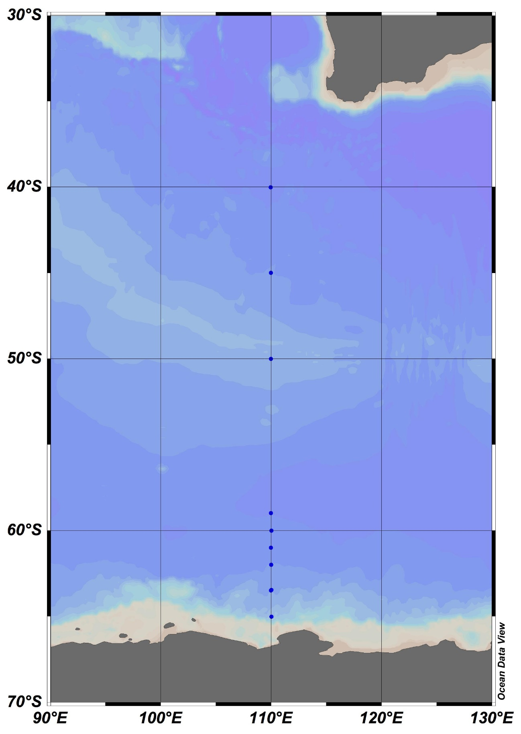

**KC2**

**D02:**

**KC6**

**D01**

**C03193**

**1**

**C02**

**C01**

**KC1**

**KC3**

**1**

**KC5**

AUSTRALIA

Fig. 2. Stations sampled with an ORI net by oblique tows on board the training vessel *Umitaka-maru*in the Indian sector of the Southern Ocean, January 2019.

ANTARCTICA