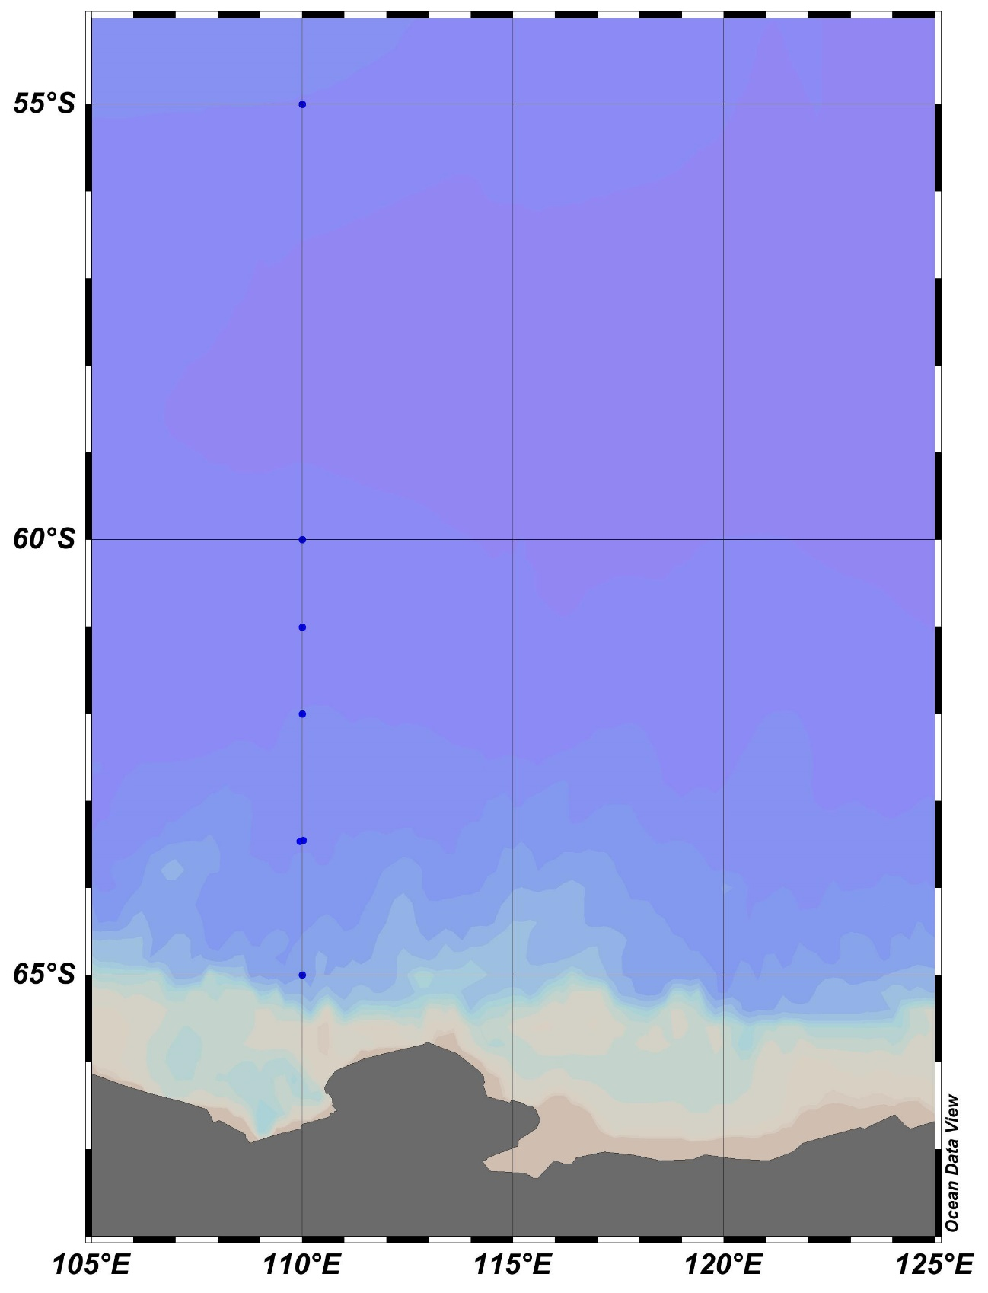

**KC5**

**C02**

**KC6**

**KC4**

**C03**

**333**

**D02**

**D03**

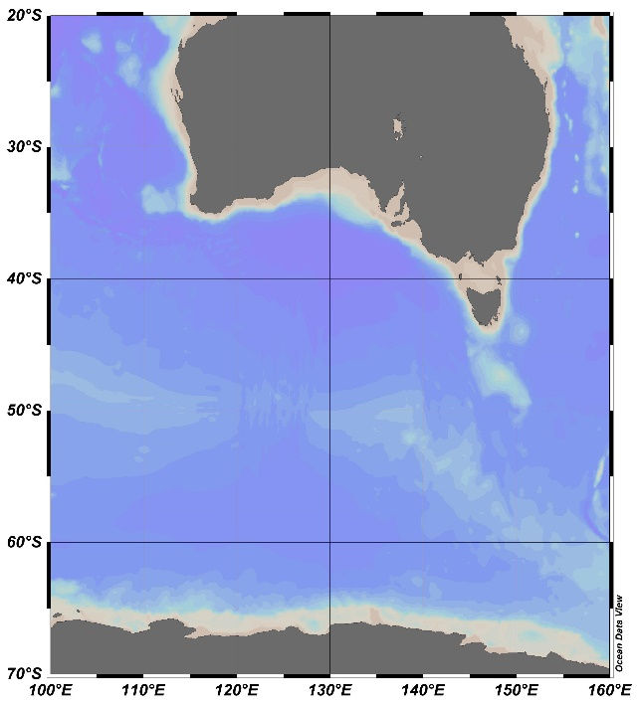

AUSTRALIA

ANTARCTICA

**A**

Fig. 1. Stations sampled with a VMPS net on board the training vessel *Umitaka-maru*in the Indian sector of the Southern Ocean, January 2019.

**A**