

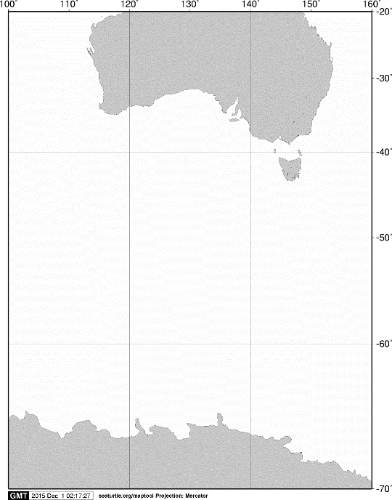

40ºS

60ºS

140ºE

120ºE

100ºE

AUSTRALIA

ANTARCTICA

20ºS

160ºE

70ºS

**A**

**A**

55ºS

**KC5**

60ºS

**D01**

**B01**

**KC6**

65ºS

125ºE

120ºE

115ºE

110ºE

105ºE

Fig. 1. Stations sampled with a VMPS net on board the training vessel *Umitaka-maru*in the Indian sector of the Southern Ocean, January 2018.