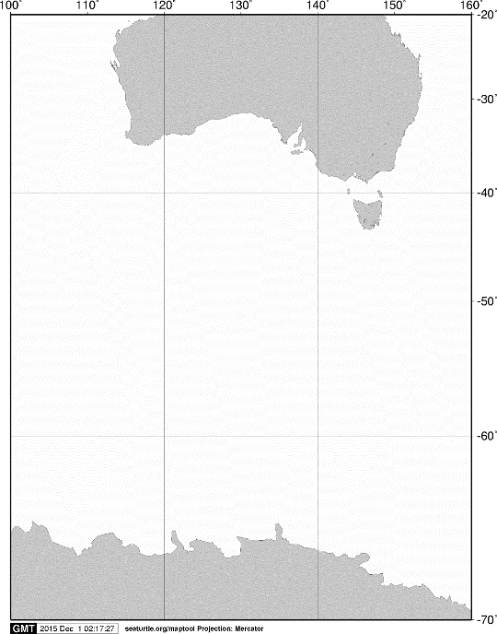

40ºS

60ºS

140ºE

120ºE

100ºE

AUSTRALIA

ANTARCTICA

20ºS

160ºE

70ºS

**A**

**A**



**KC5**

60ºS

**KM4**

**C03**

**C09**

**C07**

65ºS

**KC6**

120ºE

115ºE

105ºE

110ºE

Fig. 2. Stations sampled with IONESS opening/closing multiple-net systems from on board the training vessel *Umitaka-maru*in the Indian sector of the Southern Ocean, January 2017.