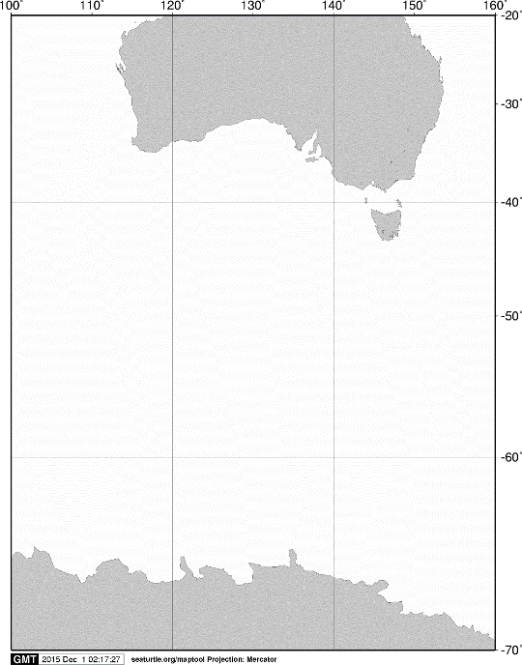

40ºS

60ºS

140ºE

120ºE

100ºE

AUSTRALIA

ANTARCTICA

20ºS

160ºE

70ºS

**A**

**A**



60ºS

**KC5**

**KM4**

**C03**

**D01**

**C05**

**C09**

**C14**

**C06**

**C11**

**C10**

**C15**

**C07**

65ºS

**KC6**

110ºE

115ºE

120ºE

105ºE

Fig. 1. Stations sampled with a VMPS net from on board the training vessel *Umitaka-maru*in the Indian sector of the Southern Ocean, January 2017.