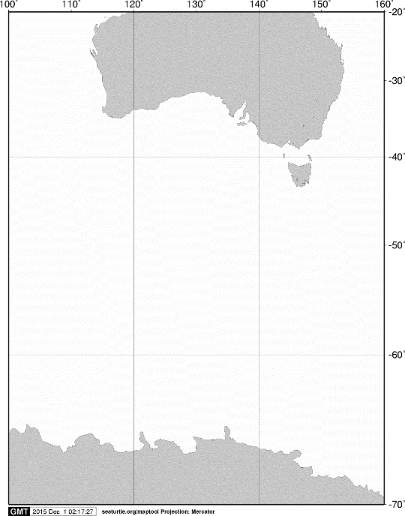

40ºS

60ºS

140ºE

120ºE

100ºE

AUSTRALIA

ANTARCTICA

20ºS

160ºE

70ºS

**A**

**A**

C:\Users\limaci07\Downloads\1480993726.tif

60ºS

**KC5**

**C02**

**C03**

**C04**

**A04**

**C05**

65ºS

**KC6**

120ºE

115ºE

110ºE

105ºE

Fig. 2. Stations sampled by vertical hauls with a twin NORPAC standard net on board the training vessel *Umitaka-maru*in the Indian sector of the Southern Ocean, January 2016.