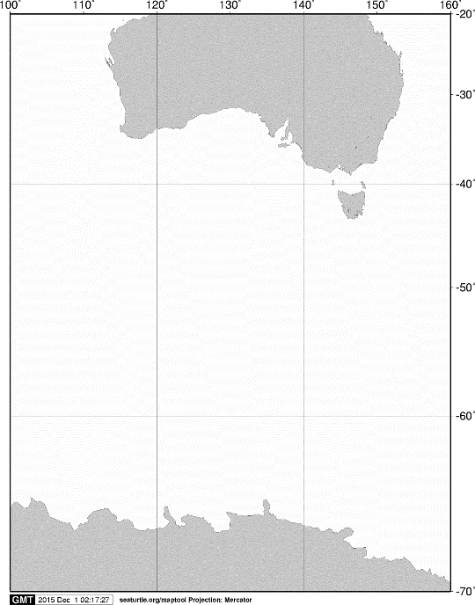

40ºS

60ºS

140ºE

120ºE

100ºE

AUSTRALIA

ANTARCTICA

20ºS

160ºE

70ºS

**A**

**A**

C:\Users\limaci07\Documents\JARE DATA REPORT\成果物\UM15\測点図\1481006079.tif

60ºS

**KC5**

**C02**

**C03**

**C04**

**C05**

65ºS

**KC6**

120ºE

115ºE

110ºE

105ºE

Fig. 1. Stations sampled by oblique hauls with an ORI net on board the training vessel *Umitaka-maru*in the Indian sector of the Southern Ocean, January 2016.