Fig. 3. Transects for CPR surveys by the icebreaker *Shirase* during JARE-57 in 2015/2016. Numbers indicate the sequential number of the CPR run. ●: Starting position, ▼: ending position.

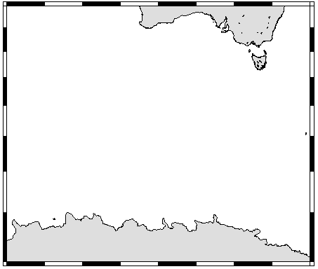

30ºS

40ºS

50ºS

60ºS

70ºS

80ºE

100ºE

120ºE

140ºE

160ºE

#1

2a

2b

5

7

6

3a

3b

4

**JARE-57 (*Umitaka-maru*)**

Fig. 4. Transect for CPR surveys by TV *Umitaka-maru* during JARE-57 in 2016. Numbers indicate the sequential number of the CPR run. ●: Starting position, ▼: ending position.

