

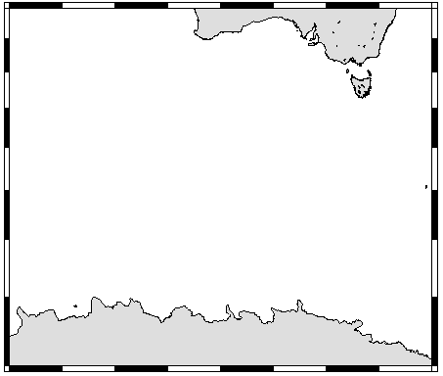

30ºS

40ºS

50ºS

60ºS

70ºS

80ºE

100ºE

120ºE

140ºE

160ºE

4

5

6

#1

2

3

**JARE-57 (*Shirase*)**

Fig. 3. Transects for CPR surveys by the icebreaker *Shirase* during JARE-57 in 2015/2016. Numbers indicate the sequential number of the CPR run. ●: Starting position, ▼: ending position.