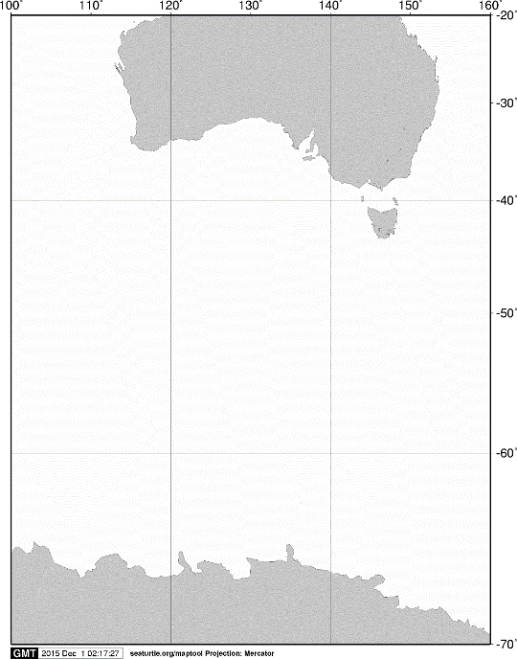

40ºS

60ºS

140ºE

120ºE

100ºE

AUSTRALIA

ANTARCTICA

20ºS

160ºE

70ºS

**A**

**A**



60ºS

**C02**

**C03**

**C05**

**C07**

**B03**

**B02**

65ºS

120ºE

115ºE

105ºE

110ºE

Fig. 2. Stations sampled with MOHT opening/closing multiple-net systems on board the training vessel *Umitaka-maru*in the Indian sector of the Southern Ocean, January 2015.