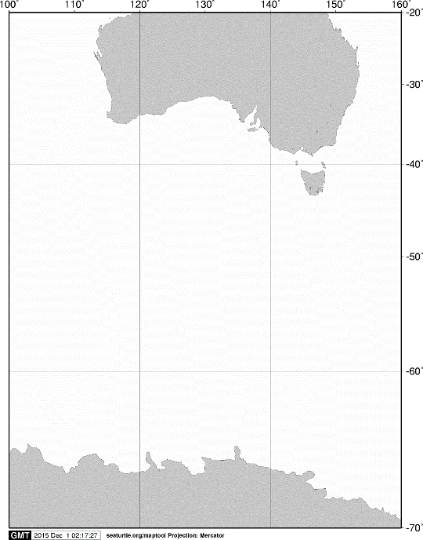

40ºS

60ºS

140ºE

120ºE

100ºE

AUSTRALIA

ANTARCTICA

20ºS

160ºE

70ºS

**A**

**A**



**KC5**

60ºS

**C03**

**A06**

**BB2**

**BB1**

65ºS

120ºE

115ºE

110ºE

105ºE

Fig. 1. Stations sampled with IONESS opening/closing multiple-net systems on board the training vessel *Umitaka-maru*in the Indian sector of the Southern Ocean, January 2015.