60°S

65°S

105°E

110°E

115°E

120°E

125°E

**A**

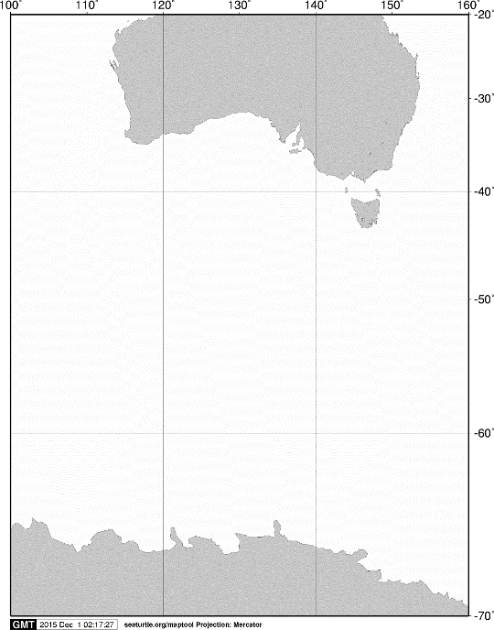

40°S

60°S

70°S

140°E

120°E

100°E

AUSTRALIA

ANTARCTICA

160°E

20°S

**A**

**KC5**



55°S

**C02**

**C032**

**C04**

**A11**

**C05**

**M02**

**A02**

**C02**

**D01**

**KC6**

Fig. 5. Stations sampled with a closing net (“Gamaguchi net”) on board the training vessel *Umitaka-maru*in the Indian sector of the Southern Ocean, January 2014.