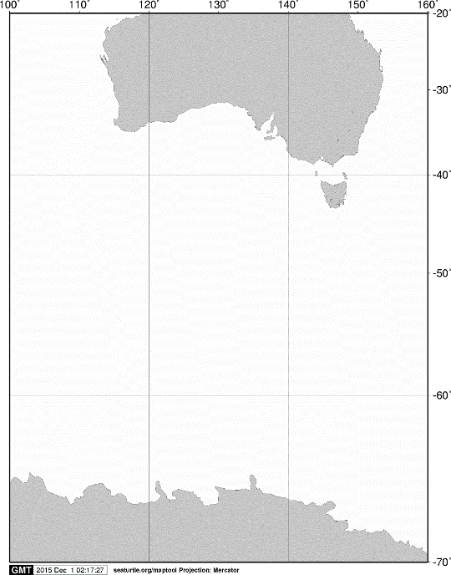

40°S

60°S

70°S

140°E

120°E

100°E

AUSTRALIA

ANTARCTICA

160°E

20°S

**A**

**A**



55°S

60°S

**A11**

**M02**

**002**

**C05**

**C06**

**A02**

**C07**

**D01**

**KC6**

65°S

105°E

125°E

120°E

115°E

110°E

Fig. 4. Stations sampled with an ORI net by oblique tows on board the training vessel *Umitaka-maru*in the Indian sector of the Southern Ocean, January 2014.