60°S

65°S

105°E

110°E

115°E

120°E

**A**

125°E

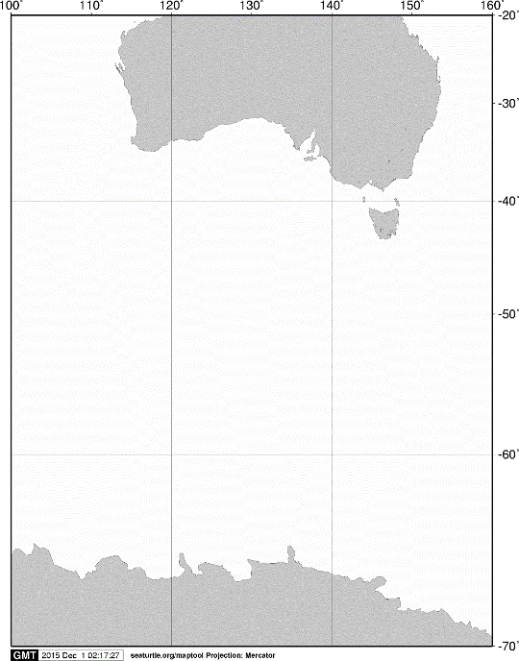

20°S

40°S

60°S

70°S

140°E

120°E

AUSTRALIA

ANTARCTICA

100°E

160°E

**A**

55°S



**KC5**

**C02**

**C03**

**A11**

**M02**

**A02**

**C05**

**KC6**

Fig. 3. Stations sampled with an ORI net by surface horizontal tows on board the training vessel *Umitaka-maru*in the Indian sector of the Southern Ocean, January 2014.