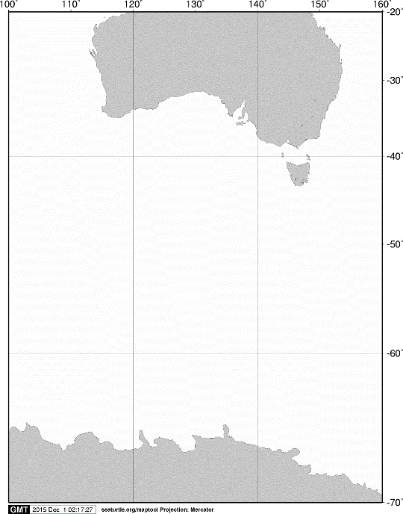

40°S

60°S

70°S

140°E

120°E

100°E

AUSTRALIA

ANTARCTICA

160°E

20°S

**A**

60°S

65°S

105°E

110°E

115°E

120°E

**A**

125°E



55°S

**C05**

**KC6**

Fig. 2. Stations sampled with RMT 1+8 opening/closing multiple-net systems on board the training vessel *Umitaka-maru*in the Indian sector of the Southern Ocean, January 2014.