60°S

65°S

120°E

55°S

125°E

**KC5**

**A**

**C02**

**C03**

**C04**

**C05**

**C07**

**C08**

**C09**

**C10**

115°E

110°E

105°E

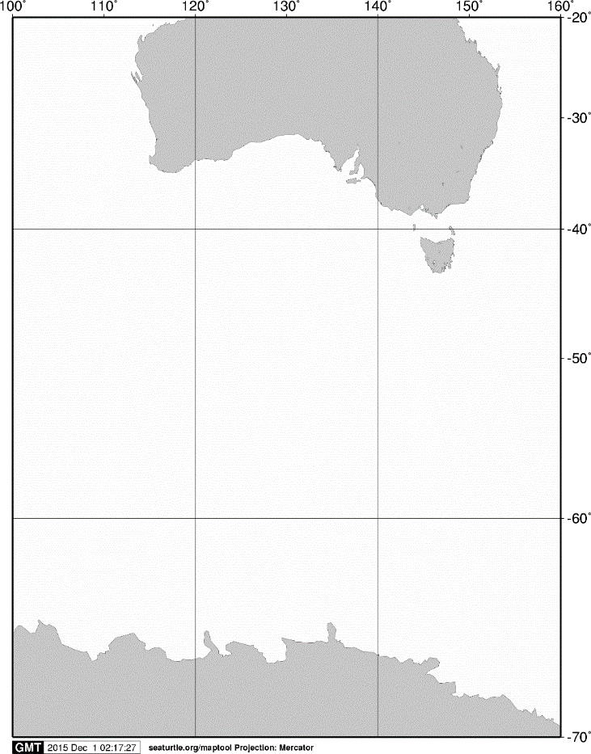

20°S

40°S

60°S

70°S

140°E

120°E

100°E

AUSTRALIA

ANTARCTICA

160°E

A



**C06**

Fi

Fig. 5. Stations sampled with a closing net on board the training vessel *Umitaka-maru*in the Indian sector of the Southern Ocean, January 2013.