

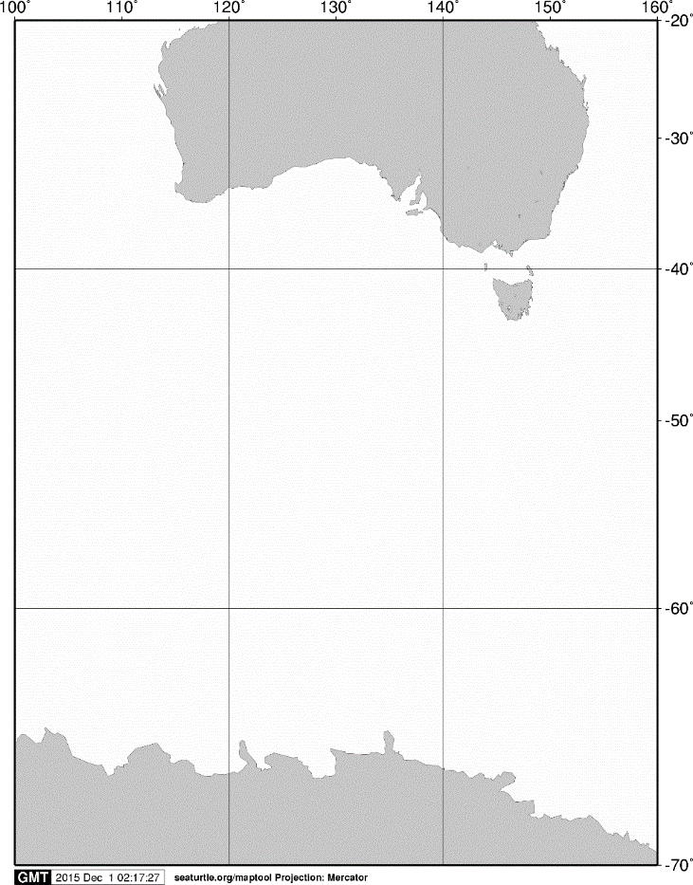

20°S

40°S

60°S

70°S

140°E

120°E

100°E

AUSTRALIA

ANTARCTICA

160°E

A

60°S

65°S

120°E

55°S

125°E

**KC5**

**A**

**C31**

**C32**

115°E

110°E

105°E

Fig. 1. Stations sampled with IONESS opening/closing multiple-net systems on board the training vessel *Umitaka-maru*in the Indian sector of the Southern Ocean, January 2013.