

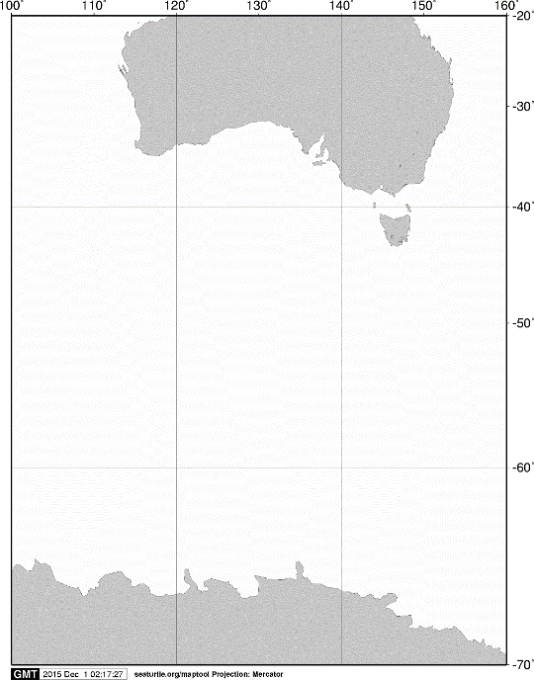

20°S

40°S

60°S

70°S

140°E

120°E

100°E

160°E

AUSTRALIA

ANTARCTICA

**A**

**A**

**D12**

**D10**

**D08**

**D07**

60°S

65°S

135°E

150°E

140°E

145°E

155°E

Fig. 1. Stations sampled with IONESS opening/closing multiple-net systems on board the training vessel *Umitaka-maru*in the Indian sector of the Southern Ocean, January 2012.



**D12**

**D10**

**D08**

**D07**

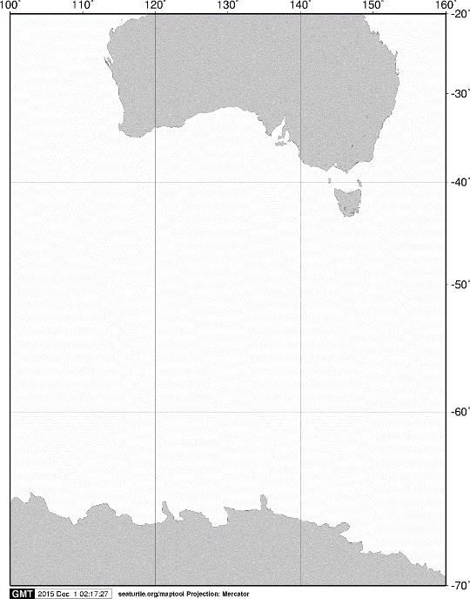

20°S

40°S

60°S

70°S

140°E

120°E

100°E

160°E

AUSTRALIA

ANTARCTICA

**A**

**A**

60°S

65°S

135°E

155°E

150°E

140°E

145°E

Fig. 2. Stations sampled with RMT 1+8 opening/closing multiple-net systems on board the training vessel *Umitaka-maru*in the Indian sector of the Southern Ocean, January 2012.



**D10**

**D08**

**D07**



20°S

40°S

60°S

70°S

140°E

120°E

100°E

160°E

AUSTRALIA

ANTARCTICA

**A**

**A**

60°S

65°S

135°E

155°E

150°E

145°E

140°E

Fig. 3. Stations sampled with an ORI net by surface towing from the training vessel *Umitaka-maru*in the Indian sector of the Southern Ocean, January 2012.





20°S

40°S

60°S

70°S

140°E

120°E

100°E

160°E

AUSTRALIA

ANTARCTICA

**A**

**D12**

**D10**

**D08**

**D07**

**A**

60°S

**D11**

**D09**

65°S

155°E

135°E

150°E

145°E

140°E

Fig. 4. Stations sampled with a twin NORPAC standard net on board the training vessel *Umitaka-maru*in the Indian sector of the Southern Ocean, January 2012.