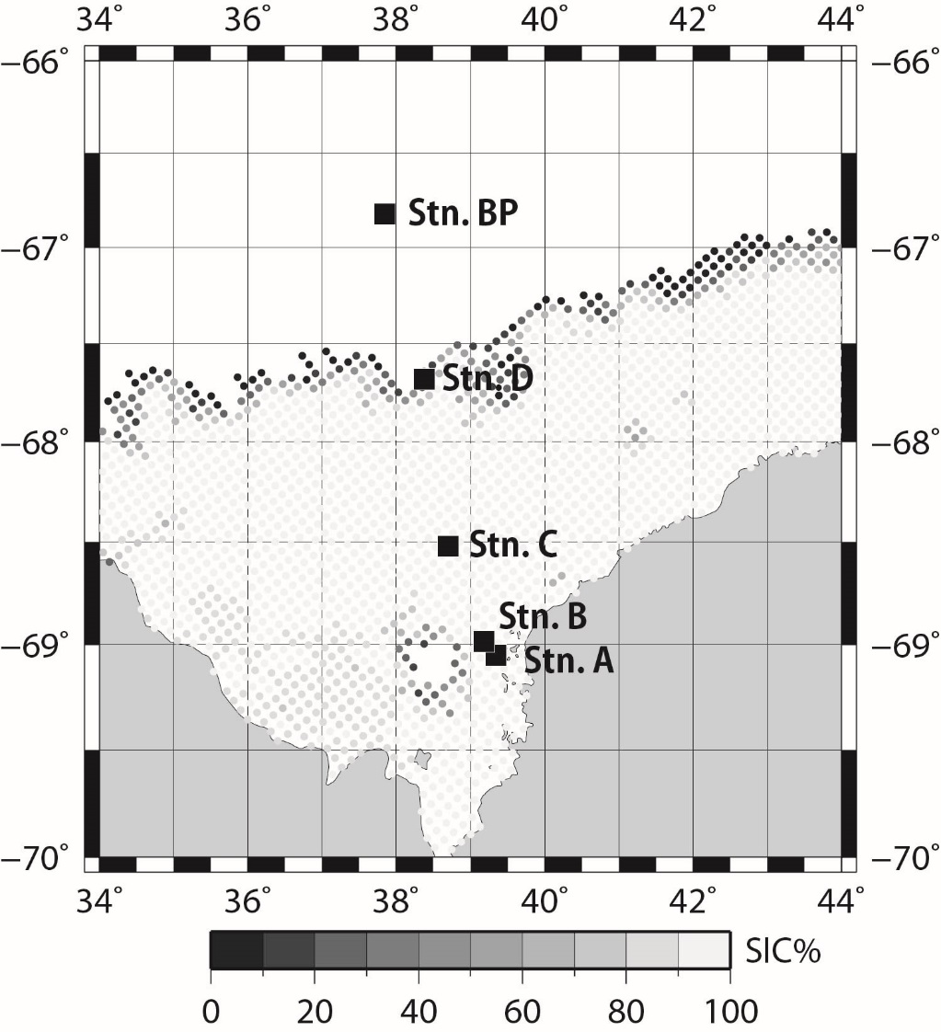

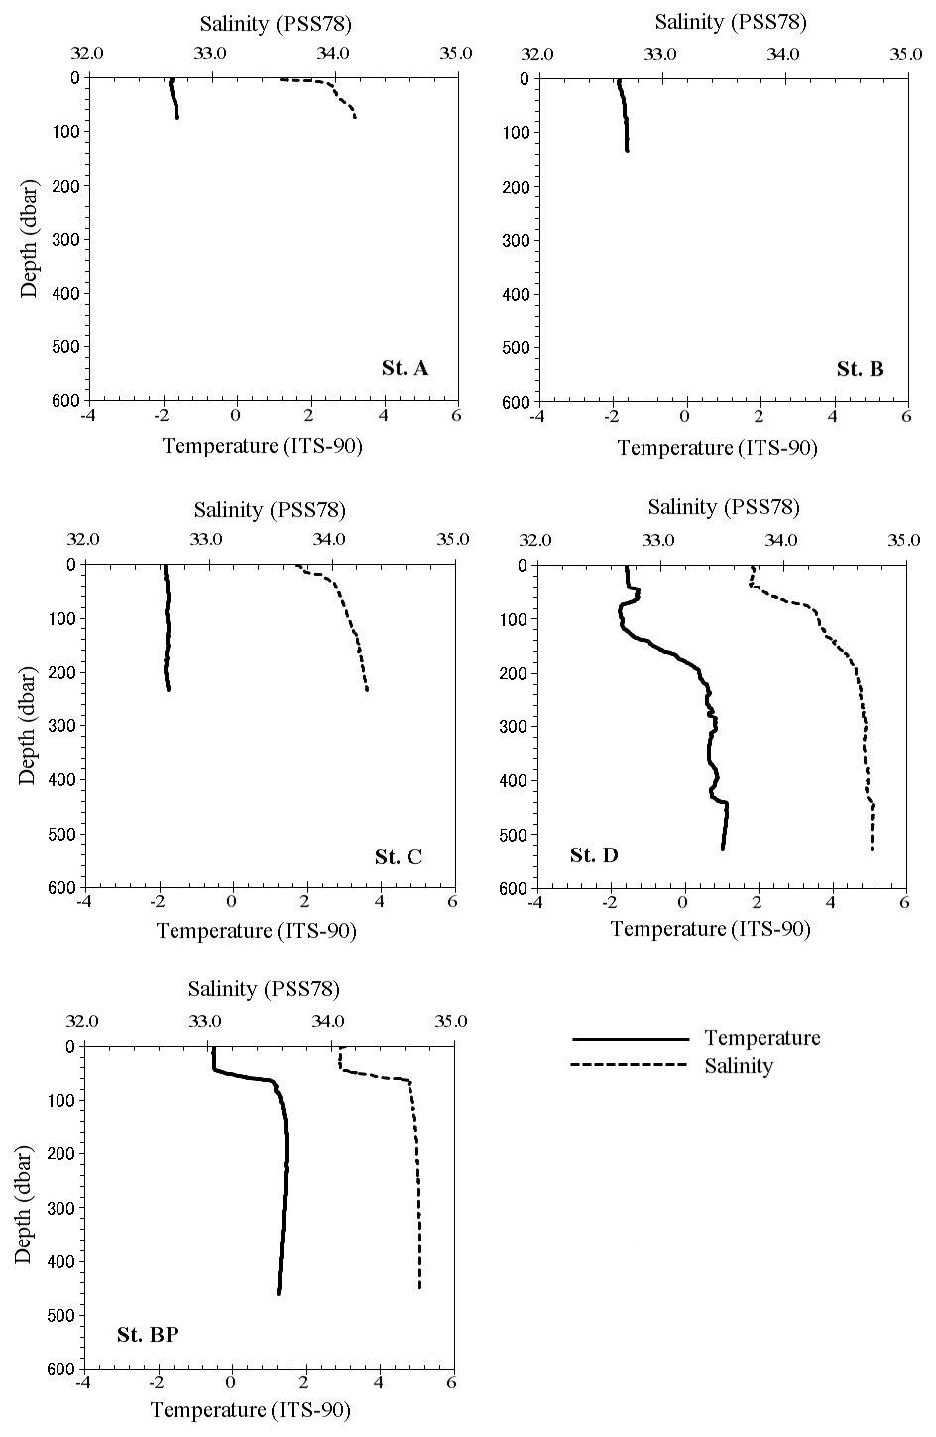

Fig. 1. Locations of sampling stations occupied during the JARE-52 cruise. Solid squares indicate hydrocast stations. SIC% indicates the sea-ice concentration on 23 February 2011. The SIC data were obtained from daily AMSR2 sea-ice maps (http://www.iup.uni-bremen.de:8084/amsr2/).

Fig. 2. Vertical profiles of temperature and salinity at the monitoring stations.