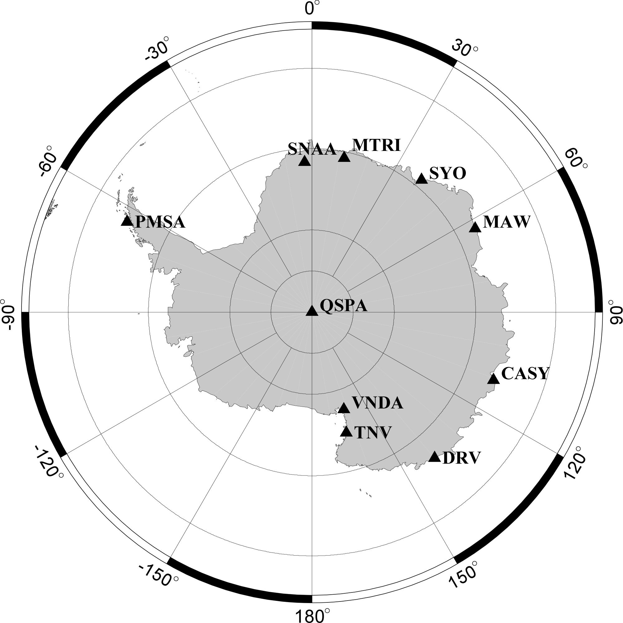
Fig. 1. Distribution of FDSN stations on the Antarctic continent in 2013. Syowa (SYO), Mawson (MAW), Casey (CASY), Dumont d’Urville (DRV), Terra Nova Bay (TNV), Vanda (VNDA), South Pole (QSPA), Palmer (PMSA), Sanae (SNAA), Maitri (MTRI).
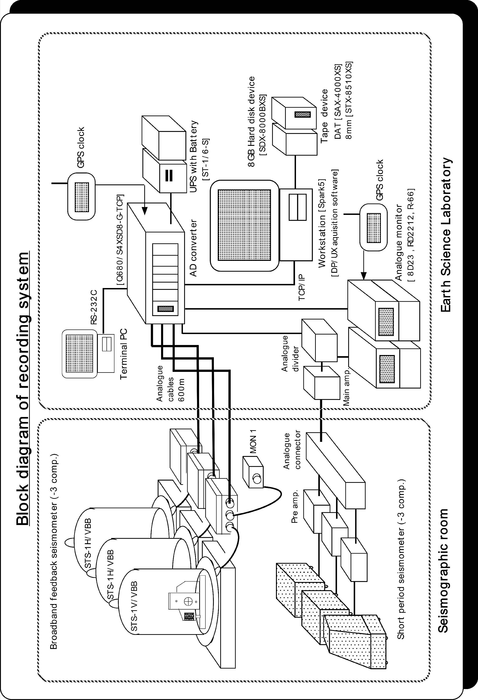
Fig. 2. Block diagram of new recording system for the STS and HES seismographs at Syowa Station. Left figure: Seismographic room; Right figure: Earth Science Laboratory.

