ICESTAR program in Japan during IPY2007-2008

Akira Kadokura^{1)*}, Natsuo Sato¹⁾, Takehiko Aso¹⁾, Hisao Yamagishi¹⁾, Hiroshi Miyaoka¹⁾, Makoto Taguchi¹⁾, Masaki Tsutsumi¹⁾, Yasunobu Ogawa¹⁾, Akira-S. Yukimatu¹⁾, Masaki Okada¹⁾, Yoshihiro Tomikawa¹⁾, Satoko Takasaki¹⁾, Yusuke Ebihara²⁾, Keisuke Hosokawa³⁾, and Kaoru Sato⁴⁾

1) National Institute of Polar Research, Kaga 1-9-10, Itabashi-ku, Tokyo 173-8515, Japan
* Corresponding author: kadokura@nipr.ac.jp
2) Nagoya University, Furo-cho, Chikusa-ku, Nagoya, Aichi, Japan
3) The University of Electro-Communications, Chofugaoka 1-5-1, Chofu, Tokyo, Japan
4) The University of Tokyo, Hongo 7-3-1, Bunkyo-ku, Tokyo, Japan

Abstract

Japanese activity corresponding to the ICESTAR program during the IPY2007-2008 period is introduced. We have proposed three EoIs (Expression of Intent) #355, #422 and #550 to the IPY2007-2008, which titles are "Program of the Antarctic Syowa MST(Mesosphere-Stratosphere-Troposphere)/IS(Incoherent Scatter) radar (PANSY)", "Interhemispheric Study on Conjugacy and Non-conjugacy of Auroral and Polar Ionospheric Disturbances using Ground-based Observation Network", and "Coordinated Radar Studies of the Arctic and Antarctic Middle and Upper atmosphere during IPY-4 period (CRSAAMU)", respectively. Those EoIs are included in the umbrella program ICESTAR/IHY. Main objective of the EoI#355 is to do feasibility studies for the PANSY. Main objectives of the EoI#422 are: (1) To maintain and intensify the conjugate observation network in both hemispheres; (2) To contribute to the international data portal, virtual observatory project with supplying our data in near-real time. Main objective of the EoI#550 is to do coordinated studies using various radar facilities; MF radar, Meteor radar, EISCAT radar, etc.

1. Introduction
ICESTAR (Interhemispheric Conjugacy Effects in Solar-Terrestrial and Aeronomy Research) is one of the proposals submitted to the IPY2007-2008 programme as the Expression of Intent (EoI). ICESTAR was merged with the other EoI, IHY (International Heliophysical Year) into a joint core project, ICESTAR/IHY (Group ID#63), which includes 24 EoIs from 22 countries in total. There are following four Thematic Action Groups (TAG) in the ICESTAR: TAG-A: Quantify and understand the similarities and differences between the Northern and Southern polar upper atmospheres, under the varying influence of the solar electromagnetic radiation and of the solar wind; TAG-B: Quantify the effects on the polar ionosphere and atmosphere of the magnetospheric electromagnetic fields and plasma populations, from the radiation belts to the tail plasma; TAG-C: Quantify the atmospheric consequences of the global electric circuit and further understand the electric circuit in the middle atmosphere as guided by the electric fields generated at the solar wind-magnetosphere interface; TAG-D: Create a data portal that will integrate all of the polar data sets and modeling results.
Space and Upper Atmospheric Science group in National Institute of Polar Research (NIPR) submitted three EoIs, #355, #422 and #550, and those were included in the ICESTAR/IHY core project. In the following sections, abstracts of the three EoIs are briefly described.

2. EoI#355
Title of the EoI#355 is "Program of the Antarctic Syowa MST (Mesosphere – Stratosphere - Troposphere) / IS (Incoherent Scatter) radar (PANSY)”, and its lead contact is Prof. Kaoru Sato in University of Tokyo. Main objective of this proposal is to do feasibility studies for the MST/IS radar at Syowa Station during the IPY period. Figure 1 is a schematic drawing of the MST/IS radar in final form. Specifications of the radar and the feasibility studies are described in detail by Tsutsumi et al. (this issue).

3. EoI#422
Title of the EoI#422 is “Interhemispheric study on conjugacy and non-conjugacy of auroral and
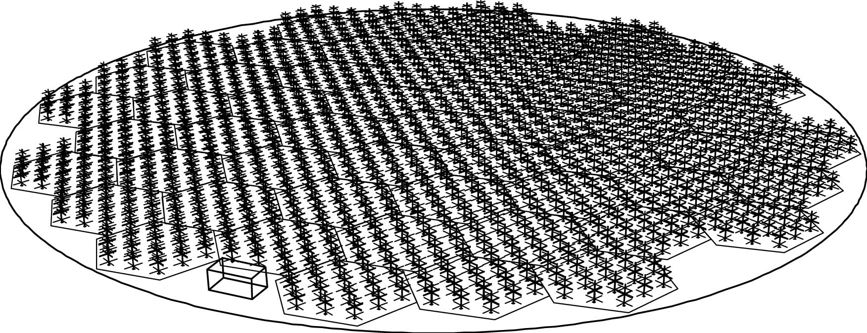
Fig. 1. Schematic drawing of the PANSY radar.

polar ionospheric disturbances using ground-based observation network”, and its lead contact is one of the authors (Akira Kadokura). Main objectives of this proposal are: (1) To maintain and intensify the Syowa - Iceland conjugate observations; (2) To develop the unmanned magnetometer network around the Syowa Station to Dome Fuji Station in the Antarctic; (3) To maintain other facilities at Syowa Station, including the two SuperDARN radars, etc.

3.1 Syowa - Iceland conjugate observations
Syowa Station in the Antarctic and the Iceland are one and almost only the ideal magnetic conjugate pair stations in the auroral latitudes. Auroral particles precipitate from the plasma sheet in the magnetosphere towards the ionosphere in the polar region in both hemispheres, and create similar auroral activities at the same time (Figure 2).
Fig. 2. Magnetic conjugate relationship between Syowa Station and Iceland.

Syowa-Iceland conjugate observation started in 1984. At present, there are three stations in Iceland, Aedey (66.09º N, -22.65º E), Husafell (64.67º N, -21.03º E), and Tjornes (66.20º N, -17.12º E). Magnetic conjugate point of the Syowa was located between Husafell and Tjornes at the beginning, and is now located very close to Tjornes. On the Antarctic side, conjugate points of the three Iceland stations moved westward during 1984 to 2007. Riiser-Larsen Peninsula is located between both conjugate points of Husafell and Tjornes, and the conjugate point of Aedey is very close to Yamato Mountains.
Syowa
Husafell and Tjornes are two major stations, where 8x8 imaging riometer is installed and auroral optical observation is carried out in the equinox seasons. A well-calibrated monochromatic all-sky CCD imager, called as Conjugate Auroral Imager (CAI), was installed at Husafell in 2005. CAI is operated automatically and continuously all through the auroral season. The same type CAI was also installed at Syowa Station in 2005. 3-axis fluxgate magnetometer, 3-axis induction magnetometer, and broad beam riometer are also installed at all the three Iceland stations. Network connection between Iceland and NIPR is via ADSL, and that between Syowa and NIPR is 1 Mbps satellite network. During the IPY2007-2008 period, Spectral instrument (e.g. Meridian Scanning Photometer) should be installed at the Iceland stations, and every data should be obtained via those networks in near real-time and should be opened for public to be widely used.

3.2 Unmanned magnetometer network
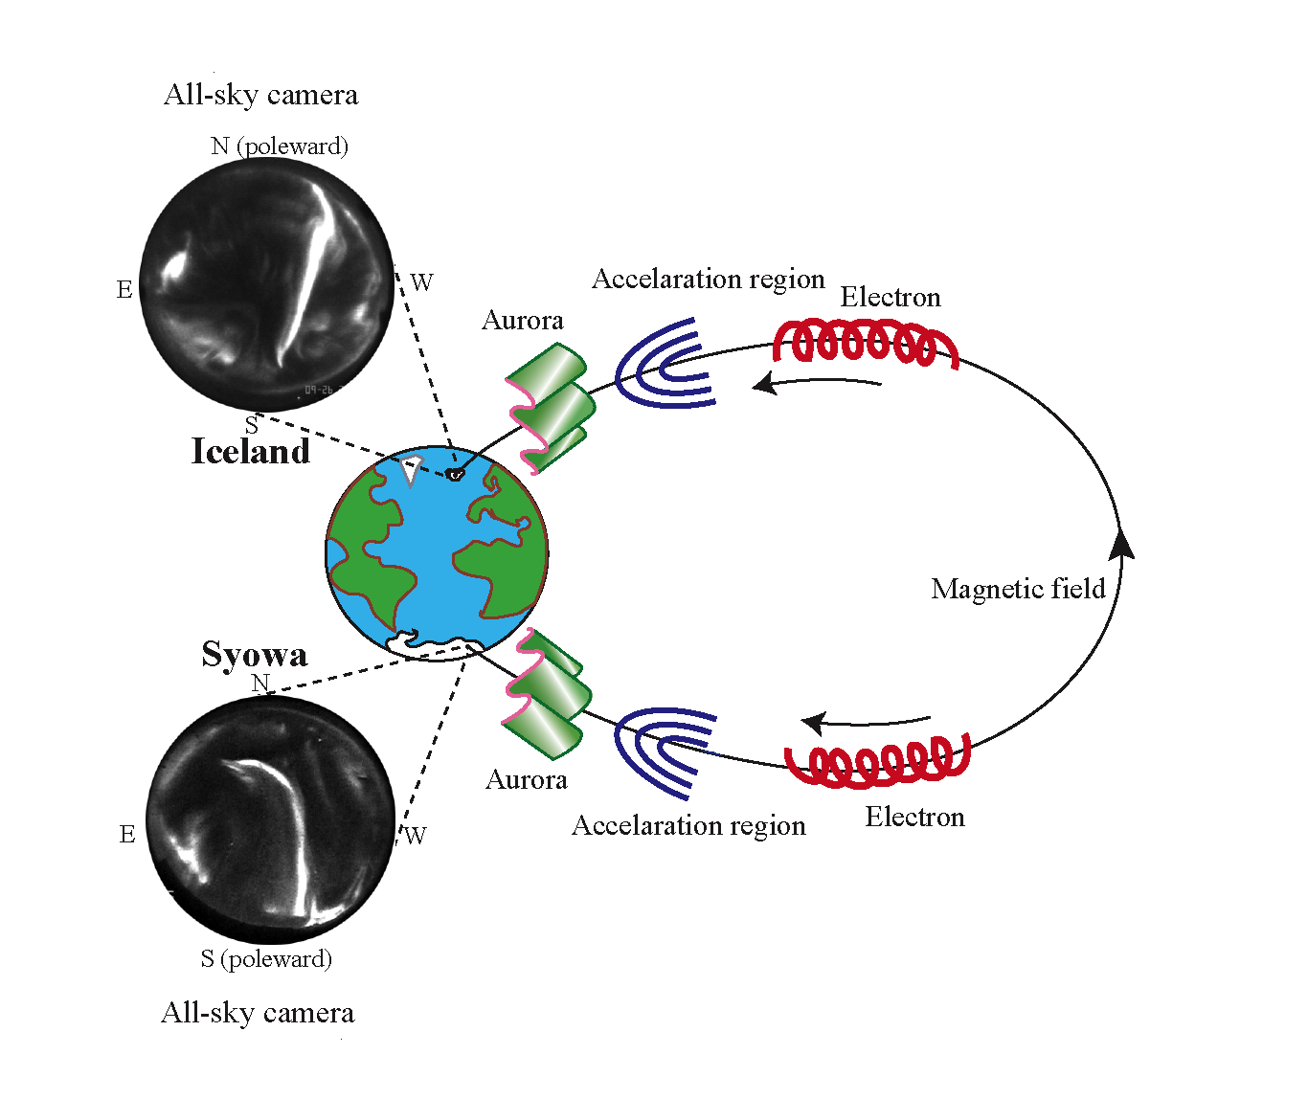
A new unmanned magnetometer network observation project in NIPR started in 2002. At present, four sets of the Low Power Magnetometer (LPM), developed at British Antarctic Survey (BAS), and two sets of the NIPR type LPM are deployed in the Antarctic. Details of this project are described by Yamagishi et al. (this issue).

3.3 Other facilities
Figure 3 (a) and (b) show the SuperDARN radar network in the northern and southern hemispheres, respectively. There are two SuperDARN radars at Syowa Station. Using these radars, ionospheric plasma convection and Polar Mesosphere Summer Echoes (PMSE) can be studied. Simultaneous observation with the unmanned magnetometer network observation can be also expected. In the northern hemisphere, simultaneous observation with the optical observation at Tjornes and the Iceland East SuperDARN radar can be expected.

4. EoI#550
Title of the EoI#550 is “Coordinated radar studies of the Arctic and Antarctic middle and upper atmosphere during IPY-4 period (CRSAAMU)”, and its lead contact is Prof. Takehiko Aso. Main objective of this proposal is to do coordinated studies using MF radar, Meteo radar, EISCAT radar, etc.

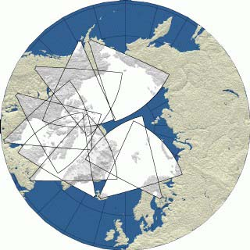
(a)

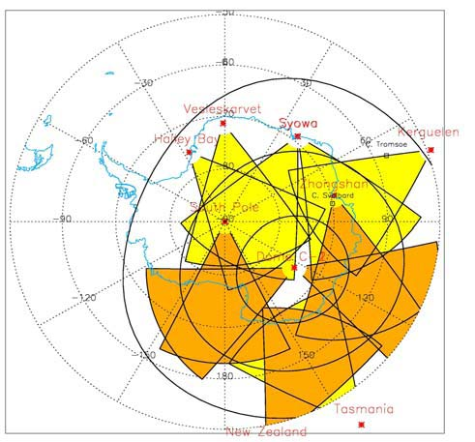

(b)
Fig. 3. SuperDARN network in the northern (a) and southern (b) hemispheres.

